**📝 Case Study: Himachal Tour Planner**

**✅ Project Title:**

**Himachal Tour Planner**

**🎯 Objective:**

To create a simple, attractive, and responsive website where users can explore popular tourist destinations in Himachal Pradesh and plan their trips using an easy-to-fill form.

**📌 Problem Statement:**

Many travelers find it difficult to plan their trips due to a lack of centralized information about destinations, dates, and activities. This project helps users plan their tour with ease and provides quick access to popular locations in Himachal.

**🛠️ Technologies Used:**

* **HTML5** – For website structure
* **CSS3** – For styling and layout
* **Google Fonts** – For modern typography
* **Unsplash** – For high-quality background images

**📋 Key Features:**

**1. Header Section**

* Contains a scenic background of Himachal.
* Includes site title and navigation bar.
* Uses text shadowing and transparent overlays for readability.

**2. Hero Section**

* Features a full-width scenic image with a title and description.
* Gradient overlay enhances visual depth.
* Responsive design with typography hierarchy.

**3. Main Content**

* **Tour Planning Form**:
  + Inputs for name, email, desired places, and preferred date.
  + Uses semantic HTML and validations (required attributes).
* **Popular Destinations List**:
  + Lists must-visit places like Shimla, Manali, Dharamshala, and Spiti Valley.
  + Clean layout and easy to read.

**📊 Impact:**

* This project creates a foundation for a travel planning platform. It streamlines the travel planning process while showcasing the cultural and natural beauty of Himachal Pradesh. It also improves user engagement through design-centric development.

**📸 Screenshots:**

**You can include the following:**

1. **Full-screen view of the home page**
2. **Close-up of the form section**
3. 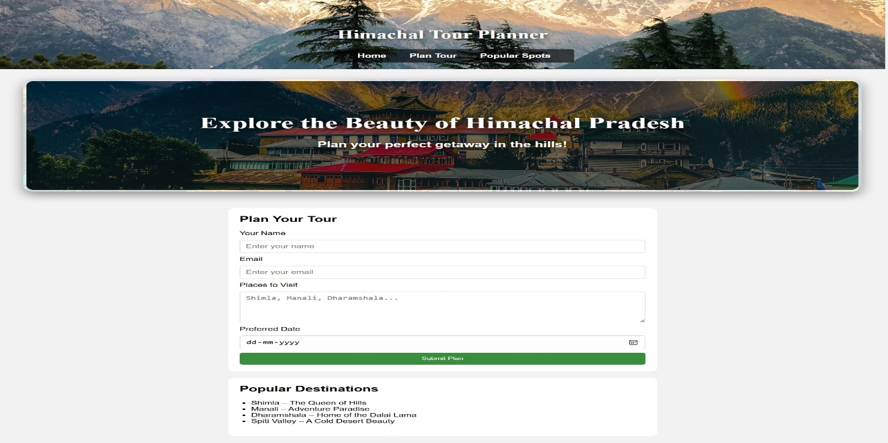**Navigation and header section with background List of popular destinations.**

**🎨 Design Approach:**

* Clean and minimal layout
* Use of large background images for visual appeal
* Responsive design for better mobile experience
* Rounded corners and shadow effects for a modern look

**💡 Learning Outcomes:**

* Improved skills in front-end development using HTML and CSS
* Learned how to design a user-friendly interface
* Understood how to structure a webpage for real-world applications

**🚀 Future Improvements:**

* Add backend to store form submissions
* Include dynamic content like weather, hotel suggestions, or maps
* Add a booking feature with confirmation email